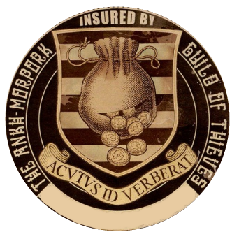

This document is proof that the holder

________________________________

Has paid premiums to the Ankh-Morpork Guild of Thieves for the year of *the Meandering Stoat*.

# The holder is hereby insured against the muggings, burglary, licenced pickpocketing and general thievery from Guild Members.

### For theft based activity from non-guild members please report said perpetrators to the Guild so that Guild representatives may ensure the removal of said thieves’ existence.